# Object: Sending a message signal on click of simple button

Steps

1. Register as Meta Developer

* Go to WhatsApp Business Cloud API - <https://developers.facebook.com/docs/whatsapp/cloud-api/get-started/>

And click on ‘Register as Meta Developer’

* You will directed to Facebook account creation dashboard. Click ‘Continue’ and Enter primary email to receive verification email

1. Create the app

* Select ‘Business’ as app type to avail all the features
* Under the ‘Provide Basic Information’ section
* Add a app name
* Primary email
* Business account [optional]
* Confirm password and save

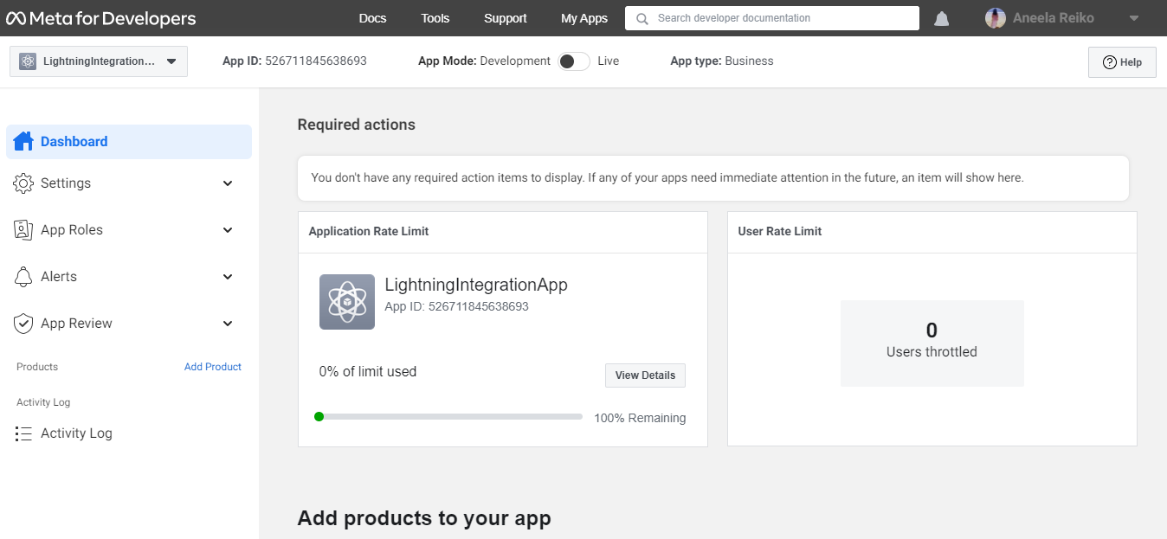

1. Scroll down and under ‘Add products to your app’ section, look for WhatsApp and click ‘Setup’ button on it. It will direct you to WhatsApp Business Platform API. Click on ‘getting started’ in left most corner

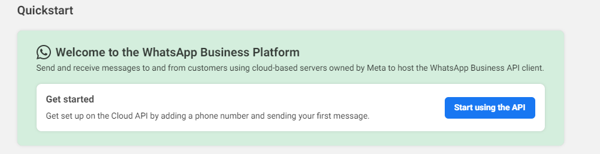

Here, you can see temporary access token

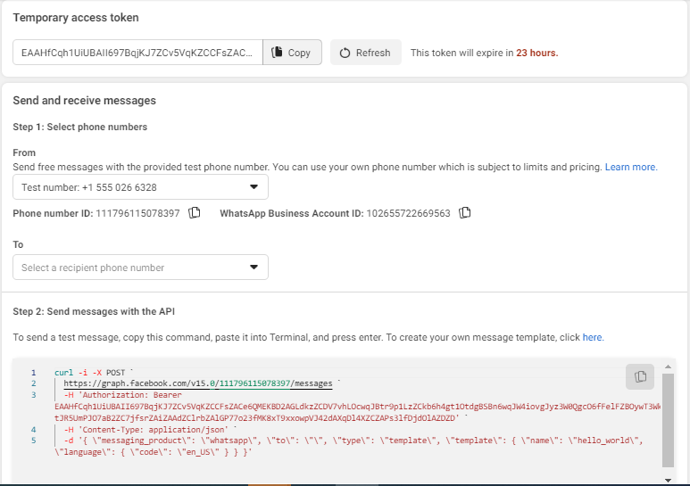

1. Enter Test Phone Number
2. Register number and send test message

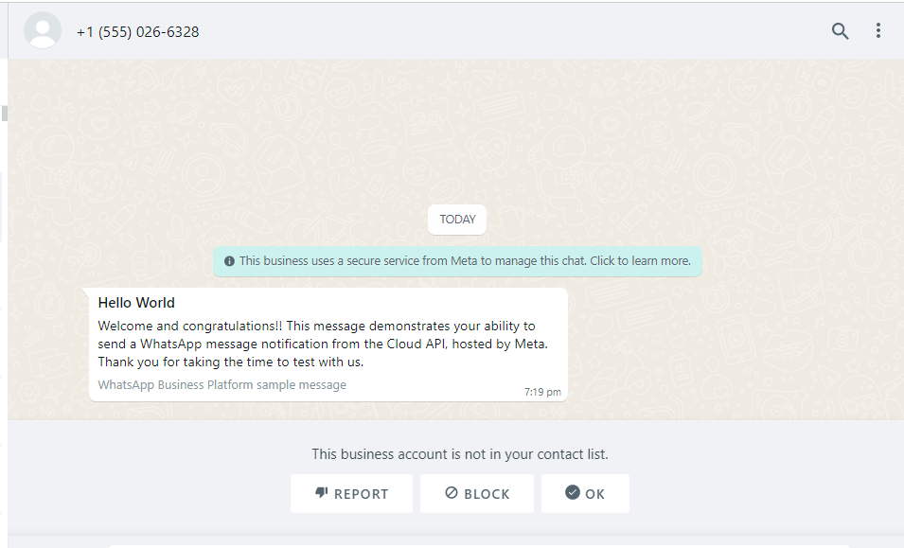

1. Configure webhooks to receive messages

Click on configure webhooks and you will get a popup box asking two fields:

Callback URL

Verify Token

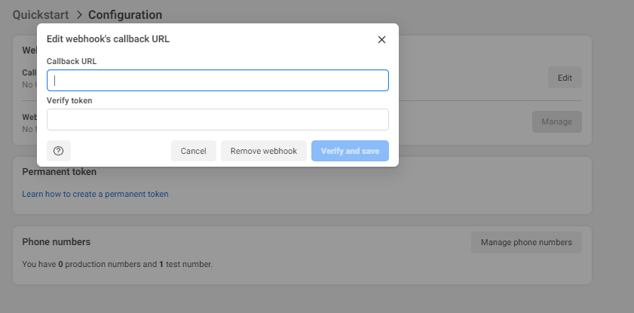

1. To get started, first you need to create the endpoint.

See [Create a Sample App Endpoint for Webhooks Testing](https://developers.facebook.com/docs/whatsapp/sample-app-endpoints#cloud-api-sample-app-endpoint) for help.

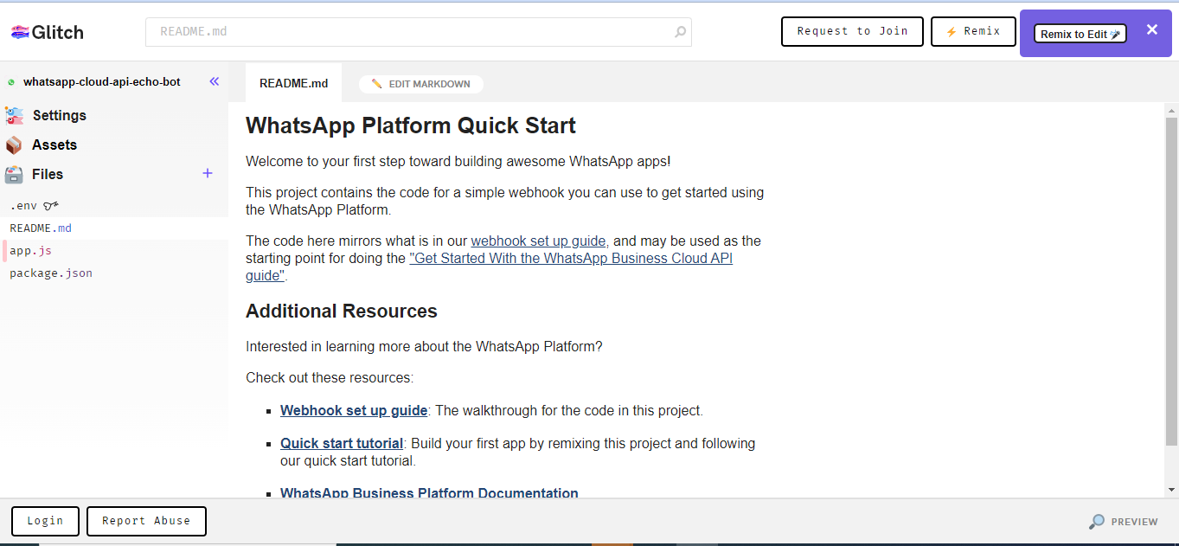

Click on the logo to direct to dashboard.

Create the project and click ‘remix’ button

<https://developers.facebook.com/docs/whatsapp/sample-app-endpoints#cloud-api-sample-app-endpoint>

Add the verify_token variable value and also provide it in env file as well. Share the live link and append ‘webhook’ at the end of url

WE ARE DONE IN OUR META DEVELOPER PART!­

# B. Create LWC Component